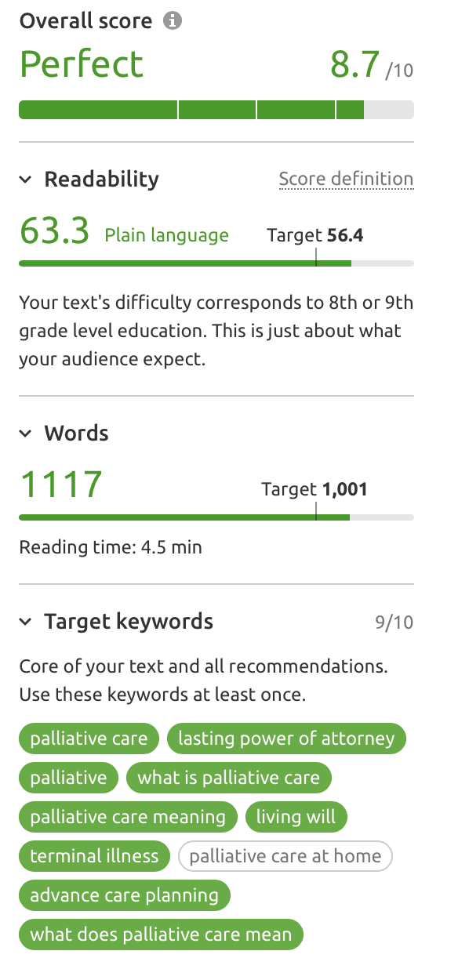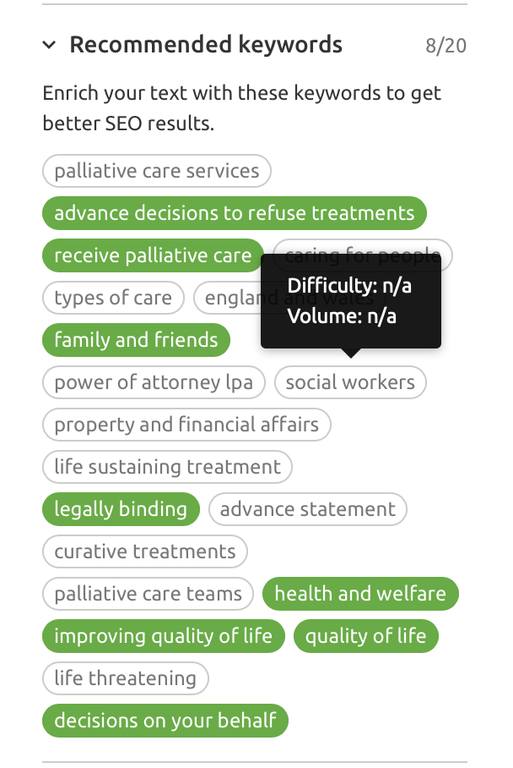

***Note Marie missing one keyword in article “Palliative care at home”***

*palliative care (33,100 – 68%)  
Lasting Power of attorney (18,100 – 74%)*

*Palliative (8,100 – 65%)*

*What is palliative care (5,400 – 89%)*

*Palliative care meaning (4,400 – 82%)*

*Living Will (3,600 – 69%)*

*Terminal illness (1,600 – 81%)*

*Palliative care at home (1,600 – 74%)*

*Advance care planning (1,600 – 82%)*

*What does palliative care mean (1,000 – 92%)*

**PALLIATIVE CARE**

We understand how upsetting it can be when you or a loved one receives the news that they have a terminal illness or that there are no further treatment options available. Whether this news comes out of the blue or following a long period of treatment, or even remission, it can understandably turn your whole world upside down in a second.

At this time, it is important to have the right care and support network in place to support you and your family. We can help you during this time, and in the weeks and months to come, by providing specialist care and support so that you can concentrate on spending time with those you love - making memories that will last a life-time.

Hospices and care homes are no longer the only options available to you. Care is evolving and as such is no longer as restrictive as it once was. In fact, there is no reason that you cannot continue to live an independent, active and fulfilling life in your own home surrounded by family and friends.

Our bespoke Palliative Care packages are tailored to your specific requirements and can change as often as your needs do, ensuring we can continue to deliver personal care and support to you, in your own home into the final stages of your life. Our advanced carers are specifically trained to support even the most complex of medical needs as well as assisting with the practical aspects of daily life, promoting comfort, independence and dignity at all times.

Our team of friendly and compassionate nurses and carers will be with you every step of the way, supporting both your physical and emotional needs, making life more comfortable for everyone involved. We look forward to meeting you and your family to discuss your needs and wishes for your Palliative Care.

See our page about (LINK) Funding Palliative Care.

**WHAT IS PALLIATIVE CARE?**

Palliative Care is designed to offer care, support and treatment to someone with a terminal, or life-limiting, illness in the final months of their life when there are no further treatment options available.

Palliative care can:

* Help to manage physical symptoms such as pain or injuries
* Support emotional, psychological and spiritual needs
* Fulfil practical needs such as washing, dressing, toileting or eating
* Providing support for family and friends

Palliative Care can be accessed at any stage of an illness and doing so does not mean that the person is likely to die soon. In fact, some people can receive palliative care for years – every case is unique. Palliative Care aims to improve the quality of life and can be delivered alongside other treatments, therapies and medicines that can help to control the progression of an illness.

[Coping with a terminal illness](https://www.nhs.uk/conditions/end-of-life-care/coping-with-a-terminal-illness): information, sources of support and tips from experts on how to cope with a terminal diagnosis.

**PLANNING AHEAD**

Planning for the final months of life is called Advance Care Planning. It involves thinking about how you would like to be cared for in the final months of your life. It may be a good idea to write down or record your views, priorities and wishes.

Although difficult, you may also need to speak to your partner or other family members to make them aware of your wishes while you are still able to. This means that if they ever have to make decisions on your behalf they will know exactly what you would want. It can also make it easier for your loved ones when you are nearing the end of your life.

Initially you may feel unable to speak to family or friends, which can lead to a feeling of isolation. But talking to those who are closest to you can help you to start to deal with your illness together.

Some of the important things to plan for include where you want to be cared for, who you would like to care for you, whether you would want to be admitted to hospital or a hospice at any point, whether you want to be resuscitated or if you want to refuse any medication.

All of these things can be included as part of your Advance Care Planning. It can also include how you would like to do things, such as how many pillows you want to sleep with, whether you prefer to keep your curtains open or closed, or even who will look after your pets when you are no longer able to do so.

An example of Advance Care Planning is the [ReSPECT process](https://www.respectprocess.org.uk/) which aims to help you discuss and document your wishes. This process is particularly useful when discussing your care with doctors and other healthcare professionals who may be part of your care team.

The most important thing is to make sure that you do what is right for you. [Planning for your future care](http://www.ncpc.org.uk/sites/default/files/planning_for_your_future_updated_sept_2014%20%281%29.pdf)  can help to guide you through this process.

[**Ways to start talking about the fact you are dying**](https://www.nhs.uk/conditions/end-of-life-care/starting-to-talk-about-your-illness)contains ideas on how to bring up the topic of your illness and the future with your loved ones.

**LIVING WILL**

A Living Will goes one step further than Advance Care Planning. Also known as an Advance Decision or Advance Decision to Refuse Treatment, a Living Will is legally binding. It allows you to make a decision to refuse treatment even if it could lead to your death.

The Living Will would come into effect if you could no longer make a decision for yourself or are unable to communicate your wishes. As the Living Will is legally binding, those caring for you must act upon your wishes.

The decision to make a Living Will is an important one, and as such should be made after considerable thought. You may want to discuss it with your partner or family first so that they are aware of, and understand, your wishes.

Read more about creating a [Living Will](https://www.nhs.uk/conditions/end-of-life-care/advance-decision-to-refuse-treatment/).

**LASTING POWER OF ATTORNEY**

When thinking about the final months of your life, an important aspect is who will help you to make decisions or make them on your behalf when you are unable to do so. This is where a Lasting Power or Attorney would come into effect. It is a legally binding document that allows you to appoint those who will help you to make decisions.

This gives you more control in the final stages of your life and helps to ensure that your wishes are observed. There are two types of Lasting Power of Attorney. One covers your health and welfare, while the other covers property and finances. You can choose whether you want to make both, or just one.

Help making a [Lasting Power of Attorney](https://www.gov.uk/power-of-attorney/make-lasting-power).